Precision Shell Moulded Castings
We are precision.
We are the part inside the machine.
"Every casting we pour is engineered for performance — shaped by fire, finished by craft, trusted by the world's most demanding industries."

Raysons Shell Cast
Precision Foundry · Kolhapur, India
"Raysons Shell Cast is a Shell Moulded and No-Bake foundry producing Cast Iron and Ductile Iron castings from 0.5 kg to 500 kg. Founded within the Raysons Group — a 40-year industrial legacy — we serve the world's most demanding OEMs across automotive, hydraulics, agriculture, railway, oil & gas, and construction equipment. Our castings have travelled to Italy, UK, Japan, and the United States — made in Kolhapur, trusted globally."

Four Pillars — appear one by one as user scrolls:

Pillar 1:
Shell Moulded Precision
In-house resin-coated sand plant. Heated metal patterns. Shells that hold tolerances conventional foundries cannot match. Surface finish that your machinists will thank you for. Parts from 500 grams to 150 kilograms are made in our foundry.
Pillar 2:
No-Bake Strength
When your casting weighs 50 kilograms — or 500 — our No-Bake line takes over. Structural components. Complex internal geometries. Heavy-walled housings. The same standard. A bigger scale.
Pillar 3:
In-House Machining
HMC. VMC. CNC Lathe. On-site. Your casting doesn't leave our facility until it's machined, dimensionally verified, and ready for your assembly line. One partner. One responsibility. Zero gaps.

Pillar 4:
Export-Ready Quality
ASTM A802. JDM B15. JDT 17015. ISO 9001. We speak the language of international quality standards — because our customers demand it, and because we've earned it.

[Three cards — clean, spec-driven, like Jesko's fleet section]

Card 1 — Shell Moulding
Shell Moulding
The process that built our reputation.
Shell moulding uses resin-coated sand applied to a heated metal pattern, forming a hard, dimensionally stable shell. The result — superior surface finish, tight tolerances, and consistency across thousands of pieces. No moisture. Easy shakeout. Lower machining cost for your team.
Weight Range | 500 gm — 150 kg
Materials | Grey Iron (IS210), Ductile Iron (IS1865), SiMo Grade
Tolerance Grade | CT8 — CT10
Surface Finish | Ra 6.3 or better
Annual Capacity | 500 MT (expanding to 700 MT)
Sectors | Automobile · Hydraulic · Agriculture · Machine Tool · Oil & Gas · Railway
Card 2- No-Bake Casting
No-Bake Casting
For when complexity demands scale.
Our No-Bake line handles the castings that shell moulding cannot — heavy structural components, complex internal cores, thick-walled housings. Furan resin. Controlled curing. Zircon wash. Exothermic risers. The weight changes. Our commitment to quality doesn't.
Weight Range | 50 kg — 500 kg
Materials | Grey Iron, Ductile Iron, SiMo Grade
Tolerance Grade | CT9 — CT11
Core Capability | Complex multi-core assemblies
NDT | UT · MPI · Visual per ASTM A802
Sectors | Automobile Railway · Oil & Gas · Construction · Export · Agriculture

Melting:
500 kg Induction Furnace — medium frequency, precise temperature control, spectro-verified chemistry before every pour.
Moulding:
Shell Shooter machines (multiple sizes) · Dump Box type shell moulding machines · No-Bake mixing and moulding line with continuous sand reclamation (expansion in progress)
Finishing:
Tumble-type shot blasting machine — 700 kg capacity. Fettling section. In-house grinding and surface dressing.
Testing & Quality:
Equipment | Capability
Bruker Q2 ION Spectrometer | Chemistry verification — every heat
Metal Soft Image Analyser | Nodularity, microstructure, nodule count
UTM HGFL Digital | UTS, Yield Strength, Elongation — mechanical testing
Hardness Tester (BHN) | Brinell hardness — every batch
Sand Testing Equipment | AFS, permeability, green strength
Ultrasonic Flaw Detector | Internal defect detection — UT
Material Handling Cranes | 5 MT capacity — safe heavy casting handling

Photos add
Vision and mission
Our Mission
To design, manufacture, and supply precision-engineered shell moulded and no-bake castings with unmatched quality and reliability.
We aim to deliver value through technological excellence, continuous innovation, and sustainable practices — ensuring long-term trust and satisfaction for our customers, employees, and stakeholders.
Our Vision
To be recognized globally as a trusted and innovative casting solutions partner, setting industry benchmarks in quality, sustainability, and customer service — driven by advanced technology, integrity, and a passion for excellence.

Our Values
Innovation: Continuously adopting new technologies and smarter processes.

Quality: Ensuring zero-defect manufacturing and superior performance.

Sustainability: Promoting an eco-friendly and safe workplace.

Integrity: Building transparent, long-term relationships with customers and partners.

Teamwork: Empowering people to grow and achieve excellence together.

Remove alloy steel from pillar 1, Add simo ductile iron, SG iron, Grey cast iron and ADI

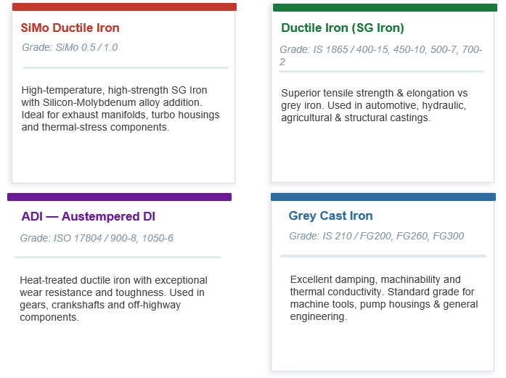
In pillar 1 and 2 write advantages of shell moulded casting and no bake castings

Shell moulding is a precision casting process widely preferred for components requiring superior surface finish, dimensional consistency, and repeatability.
Compared to conventional green sand moulding processes, shell moulding offers several advantages for medium to high-volume precision components.
Advantages of Shell Moulded Castings
- Superior surface finish
- Better dimensional accuracy
- Reduced machining requirements
- Excellent repeatability for OEM production
- Suitable for complex and precision components

No-bake casting is preferred for medium to large-sized castings where strength, flexibility, and dimensional stability are essential.
Compared to conventional moulding methods, no-bake technology offers greater flexibility for complex and heavy castings.
Advantages of No-Bake Castings
- Ideal for large and heavy castings
- Better dimensional stability
- Flexible for complex geometries
- Improved mould strength and casting quality
- Suitable for customized industrial components

01 Raw Material Inspection
Careful inspection and testing of incoming raw materials to ensure consistent casting quality from the very beginning.

02 Sand Preparation & Shell Formation
Controlled sand properties and precise shell formation for superior mould strength and dimensional accuracy.

03 Melting & Metallurgical Control
Monitored melting practices and metallurgical control to achieve the required chemical and mechanical properties.

04 Precision Pouring Process
Optimized pouring parameters and process discipline to ensure defect-free and reliable castings.

05 Fettling & Surface Finishing
Controlled fettling and finishing operations for clean surfaces, improved appearance, and dimensional consistency.

06 Machining, Inspection & Dispatch
Final machining, quality inspection, and dispatch processes carried out to meet customer specifications and delivery requirements.

Main page:

About us:
Raysons Group is a Kolhapur, India based group having diversified businesses activities, with operations in Manufacturing of Resin Coated Sand, Manufacturers of Shell Moulded Castings Foundry, Construction , Hospitality and Wind Power. With vision of our founder Mr. B.G. Raibage since it’s inception in 1974, Raysons has developed in varied business lines and has created a Trusted brand. Our policy to manufacture a top quality product and to be pioneer in the field. We are committed for quality and customer satisfaction though continuous improvement. We at Raysons believe that quality is the base for our achievement and ultimate customer satisfaction is our objective. At the turn of the millennium, Raysons Group diversified into Hospitality sector and is looking forward to enter into various ventures like IT parks, Retail (Mall) and Entertainment Avenues. Kolhapur is on roll and Raysons Group is proud to be a part of Kolhapur’s development.

Our Mission
To design, manufacture, and supply precision-engineered shell moulded and no-bake castings with unmatched quality and reliability.
We aim to deliver value through technological excellence, continuous innovation, and sustainable practices — ensuring long-term trust and satisfaction for our customers, employees, and stakeholders.

Our Vision
To be recognized globally as a trusted and innovative casting solutions partner, setting industry benchmarks in quality, sustainability, and customer service — driven by advanced technology, integrity, and a passion for excellence.

Our Values
Innovation: Continuously adopting new technologies and smarter processes.
Quality: Ensuring zero-defect manufacturing and superior performance.
Sustainability: Promoting an eco-friendly and safe workplace.
Integrity: Building transparent, long-term relationships with customers and partners.
Teamwork: Empowering people to grow and achieve excellence together.

Time line:
Our Journey of Growth & Innovation

1987 – Foundation of Raysons Industries
Raysons Industries was established, becoming the first manufacturer of Resin Coated Sand (RCS) in Maharashtra, pioneering a new era of quality foundry materials in the region.

1992 – Expansion with SBR Unit
To meet growing demand, we set up our second manufacturing unit under SBR, expanding our production capacity and customer reach.

1995 – ISO Certification
Raysons SBR achieved ISO certification, marking our commitment to international quality standards and consistent process excellence.

1997 – Inception of SRI Durga Mata
We diversified operations by establishing SRI Durga Mata, further strengthening our position in the foundry and allied industries.

2002 – Launch of RR Sand Industries
To support the growing requirements of bonding and coating materials, we founded RR Sand Industries, adding another specialized division under the Raysons Group umbrella.

2005 – Raysons Sand Chem Pvt. Ltd.
We commissioned Raysons Sand Chem Pvt. Ltd., a state-of-the-art manufacturing plant with a production capacity of 3,000 tons per month, enabling us to serve larger domestic and export markets.

2021 – Establishment of Raysons Shell Cast
Raysons Shell Cast was founded with a 450-ton monthly melting capacity, marking our entry into shell moulded casting manufacturing — offering precision-engineered castings to leading industries.

2022 – Introduction of No-Bake Foundry Line
To meet the growing demand for larger and complex castings, we commissioned a modern No-Bake foundry line, further expanding our technical capabilities and production flexibility. 2026 – Advanced Machine Shop Setup
To move towards complete value-added solutions, Raysons Group will establish a dedicated CNC and VMC-equipped machine shop, enabling fully machined casting deliveries for customers across valve, pump, and automotive industries.

2026 – In-House Heat Treatment Facility

A new heat treatment plant will be introduced to ensure consistent metallurgical properties and offer ready-to-assemble castings, strengthening our one-stop manufacturing capabilities.

2027- More new HMC and Vmc Machine additions

Addition of review and FAQS

